Types of Prepositions
# Source: AI Source: Provided by: [Data Path: Persons Table -> ID Column: 1, Name_En Column: Motasem Essam] -> From: [Chatgpt (GPT-4-turbo)] on [7/28/2025]
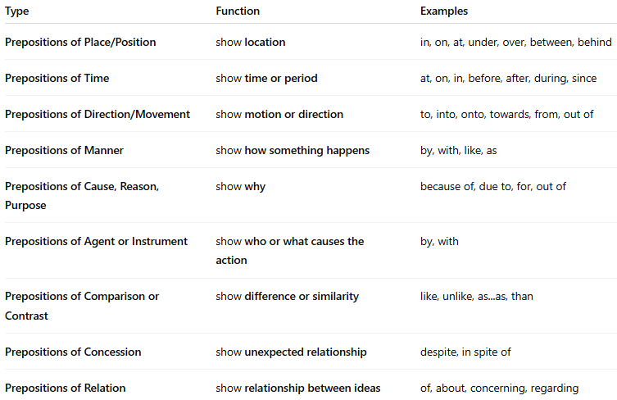

Type | Function | Examples
Prepositions of Place/Position | show location | in, on, at, under, over, between, behind
Prepositions of Time | show time or period | at, on, in, before, after, during, since
Prepositions of Direction/Movement | show motion or direction | to, into, onto, towards, from, out of
Prepositions of Manner | show how something happens | by, with, like, as
Prepositions of Cause, Reason, Purpose | show why | because of, due to, for, out of
Prepositions of Agent or Instrument | show who or what causes the action | by, with
Prepositions of Comparison or Contrast | show difference or similarity | like, unlike, as...as, than
Prepositions of Concession | show unexpected relationship | despite, in spite of
Prepositions of Relation | show relationship between ideas | of, about, concerning, regarding

